**Save the Date!**

**June 25 – June 27**

Camping and Canoeing on the Russian River

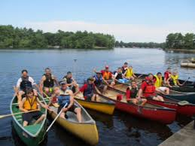

**Troop 325**

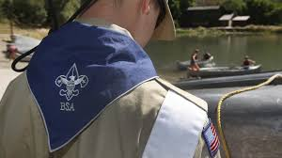

8600 River Rd, Forestville, CA

**Burke’s Canoe Trips**

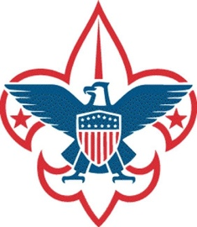

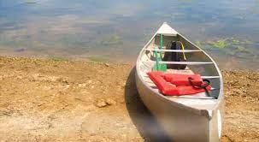

* Drive up to Forestville on Friday afternoon
* Set up Camp next to the River
* Campfire with Skits n’ Songs
* Saturday 4-hour Canoe Trip down the river with lunch on a Gravel Bar
* Shuttle takes us back to Camp
* Free time in Camp for games & fun
* Campfire games, songs, and fun
* Sunday break camp and drive home

Let’s go make memories for 2021!